SQL Murder Mystery: “Who Killed the CEO?”
The CEO of TechNova Inc. has been found dead in their office on October 15, 2025, at 9:00 PM.
You are the lead data analyst tasked with solving this case using SQL. All the clues you need are hidden in the company’s databases:
- Keycard logs
- Phone call records
- Alibis
- Evidence found in different rooms
Your mission is simple but challenging:
👉 Find out who the killer is, where and when the crime took place, and how it happened — using only SQL queries.
Use this File to create tables with data:
-- Identify where and when the crime happened
select room as crime_location,
entry_time as crime_time FROM keycard_logs
where room = 'CEO Office'
order by entry_time;
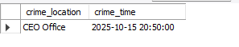

-- Analyze who accessed critical areas at the time
SELECT
e.employee_id,
e.name,
e.department,
e.role,
k.room,
k.entry_time,
k.exit_time
FROM employees as e
join keycard_logs as k
on e.employee_id = k.employee_id
where entry_time between '2025-10-15 20:50:00' and '2025-10-15 21:00:00';

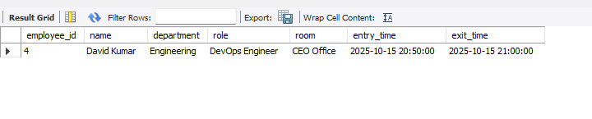
-- Cross-check alibis with actual logs

WITH cte_alibi AS (
SELECT
employee_id,
claimed_location,
claim_time
FROM alibis
WHERE claim_time = '2025-10-15 20:50:00'
),

cte_logs AS (
SELECT
employee_id,
room AS actual_location,
entry_time,
exit_time
FROM keycard_logs
WHERE room = 'CEO Office'
)

SELECT
e.name AS employee_name,
a.claimed_location,
a.claim_time,
l.actual_location,
l.entry_time,
l.exit_time

FROM cte_alibi a
LEFT JOIN cte_logs l
ON a.employee_id = l.employee_id
LEFT JOIN employees e
ON a.employee_id = e.employee_id;

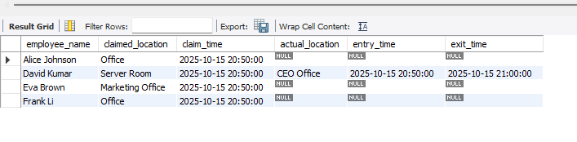
-- Investigate suspicious calls made around the time
SELECT
e.name as caller_name,
call_time,
duration_sec,
e2.name as call_reciver
FROM calls c
join employees e
on c.caller_id = e.employee_id
join employees e2
on c.receiver_id = e2.employee_id
where call_time between '2025-10-15 20:50:00' and '2025-10-15 21:00:00';

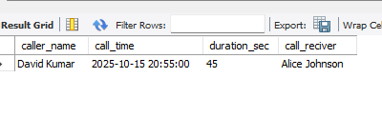
-- Match evidence with movements and claims
SELECT
ev.room,
ev.description,
ev.found_time,
e.name AS suspect_name,
a.claimed_location,
kl.room AS actual_location,
a.claim_time,
kl.entry_time AS actual_entry_time,
kl.exit_time AS actual_exit_time,
ca.call_time
FROM evidence ev
JOIN keycard_logs kl
ON ev.room = kl.room
JOIN alibis a
ON kl.employee_id = a.employee_id
JOIN employees e
ON e.employee_id = kl.employee_id
LEFT JOIN calls ca
ON ca.caller_id = e.employee_id
WHERE ev.room = 'CEO Office'
AND kl.entry_time BETWEEN '2025-10-15 20:45:00' AND '2025-10-15 21:15:00';
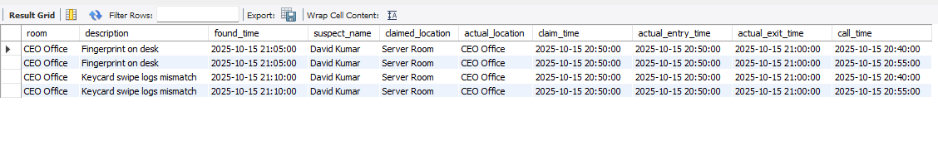
-- Combine all findings to identify the killer
with cte_find_killer as
(
select employee_id, claimed_location, claim_time
FROM alibis
where claim_time = '2025-10-15 20:50:00'
),
cte_key_card as
(
select employee_id, room as crime_location,
entry_time as crime_time FROM keycard_logs
where room = 'CEO Office'
order by entry_time
)
SELECT e.name FROM cte_find_killer a
join cte_key_card as k
on a.employee_id = k.employee_id
left join employees e
on a.employee_id = e.employee_id;
